Geography:  Hot places  The children will learn how people, plants, and animals survive in deserts. They will compare a variety of deserts such as  The Saharan and Arabian deserts. | Computing  Online Safety  Pictograms  The children will learn to create pictograms using a variety of data. | Science  Animals including humans.  As scientists, we will continue to deepen our understanding of what we need to survive and look closer into life cycles. | RE  How should we care for others and the world and why does it matter?
English  How the tortoise got his shell  Imitate: The children will learn the story using key language and actions.  Innovate: The children will learn to change certain parts of the text such as characters, settings.  Invent: The children will write their own version of the story.  Non-fiction: | Key Topic Question  Our Class book  Our Key Virtues  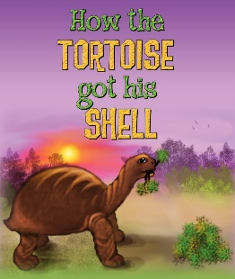  All Creatures Great and  Small Excellence  ‘What is it like in  the wild? |  | Maths  Our Maths learning this term will focus on:  Measurement: weight temperature  Statistics: Tally charts, drawing and interpreting pictograms.  Position & Direction: Describing movements and turns.
PE  The children will learn a variety of team building games to improve key skills and understanding. | Music  Reﬂect, Rewind and Replay  To listen and appraise different songs, find the pulse, beat and tempo. | PSHE  The children will learn about how they grow and change, both physically but also mentally and emotionally. | Art  Life in Colour  The children will explore colour, texture and form through paint and a variety of mixed media.
Wow Moment Enquiry Day: Mark’s Ark | Fabulous Finish: End of year 2 celebrations
Enrichment opportunities
- Visits to the zoo, aquarium etc
- Exploring your local environment -your garden, the woods, rockpools – what animals, insects, sea life can you find?

Suggested Learning Opportunities at Home:
- Homework grid
- Numbots and TTRS (Maths)
- Writing opportunities where possible -shopping lists, what do they need for the day at the beach? Information booklet about their favourite animals.

