Maths  We will continue to develop methods to solve multiplication and division problems whilst also improving our fluency in times tables. Children will also learn about  length and perimeter. | Computing  This unit introduces working through data handling concepts, and does so utilising the  features of Microbit hardware. These micro-controllers give children a really hands-on experience with programming, seeing what they code appear physically before their eyes. | RE  In RE, children will answer the question: What does it mean to be a Hindu in Britain today? They will explore how Hindus show their beliefs and make connections with some Hindu beliefs and teachings about aims and duties in life. | Science  Children will recognise that living things can be grouped in a variety of ways; and explore and use classification keys to help group, identify and name a variety of living things in their local and wider environment.
English  In English, children will study ‘The Wind in the Willows’, innovating the text to create their own character description. The children will also create a newspaper report linked to their learning on the environment. | Our Class book  The Wind in the Willows  Kenneth Grahame  Key Question:  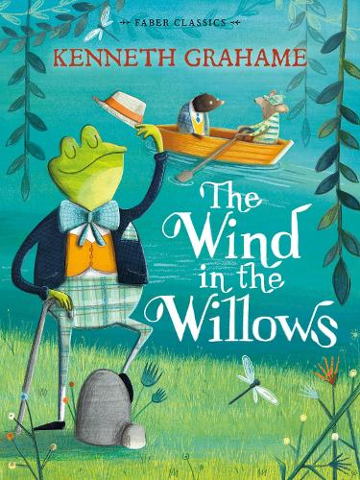  Water, water everywhere but where does it come from? |  | Geography  In Geography we will identify the parts of a river and learn about the water cycle. We will learn about the many uses for rivers around the world, including cleaning, cooking, growing crops, transport and creating power. We will also learn about flooding.
PE  For indoor PE, we will focus on dance. Outside, the children will be learning the skills to play netball. | Music  In Music, children will learn the ‘Stop!’ grime track before innovating their own class song about a change they would like to see in the world. | PSHE/ Spanish  In PSHE, we will focus on keeping ourselves safe. In Spanish, the children will learn about the shopping experience in Spain. Children will learn specific vocabulary of fruit,  vegetables and clothes. They will learn key phrases for asking the questions needed when going shopping. | Art/DT  In Art we will be studying repeat patterns and creating our own inspired by nature. We will look at the work of William Morris and look at existing textile patterns. Using mechanical engravings as a starting point, the children will develop an awareness of proportion, composition and pattern in drawing and combine media for effect when developing a drawing into a print.

