Geography  Children will continue their knowledge of the world by explore North America, its climate and why people choose to live there. | Computing  Children will develop our own online books using book creator. In addition to learning about how to stay safe online. | Science  Children will explore the topic animals, including humans. They will learn about the types of food and their nutrition values. They will learn to identify different skeletons for both humans and animals and they will begin to investigate the role of muscles. | RE  Children will explore the question ‘Why is the bible important for Christians today?
English  GPS skill focus – Prefixes and present perfect verbs  Our T4W text is The Little Read Riding Hood, we will continue to embed key writing skills such as paragraphs, sentence structure, inverted commas and fronted adverbials. We will then work on non-chronological writing around being and keeping healthy. | Brains and Bodies!  Our Key Virtues  Our Class book  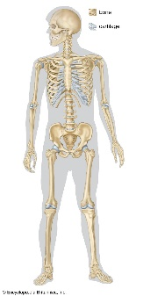  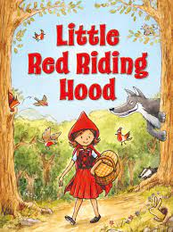  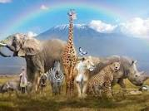  Honesty  What is under our skin? |  | Maths  In maths, we will develop our knowledge of time. Children will also explore geometry and shape. They will also look at statistics through their plastic free work.  In number fact sessions, we will continue to work on our rapid recall of the 3, 4 and 8 times tables.
PE  Children will learn key skills with a specific focus on athletics ahead of sports day. They will also learn the team sport, rounders alongside completing a block of swimming lessons. | Music  In Music, the children will learn to listen and appraise a variety of classical music. | PSHE/ Spanish  In PSHE, we will use SCARF to explore ‘Growing and Changing’  In Spanish, we will be taught to tell the time, say dates and months. | Art/DT  Children will explore the nutritional values of seasonal food and explore creating savoury tarts! Children will create an end of year self portrait inspired by artwork and artists they have explored this year.

Wow Moment Enquiry Day:  Special animal visitors! | Fabulous Finish:  Dissecting owl pellets
Enrichment opportunities
- Internal animal visit
- Continue SAS work – Litter pick around school and at the SANG.

Suggested Learning Opportunities at Home:
- Continued Times Tables practise
- Reading daily
- Spelling practise
- Homework grid on Google Classroom

